**Risk in the Community and Children Missing from a Foster /Supported Lodgings Carer’s Home Guidance**

**Document last updated:** June 2023

**Document review date:** June 2026

# **About This Document**

|  |  |
| --- | --- |
| Title | Children missing from a foster /supported lodgings carer’s home guidance |
| Purpose | **Guidance for Foster Carers and Supported Lodgings Carers** |
| Updated by | **Rosemarie Cronin, Fostering Panel Advisor, Shane Thomson, Missing Co-ordinator, Lucy Stovell (Senior Co-ordinator for Specialist Involvement, Sally-Ann Millar (ESCB Child Exploitation Project Manager)** |
| Approved by | **Fostering Board** |
| Date | **October 2023** |
| Version | **8.0** |
| Status | **Approved** |
| Review Frequency | **Three-Yearly** |
| Next Review Date | **October 2026** |

# **Version Control**

|  |  |  |  |
| --- | --- | --- | --- |
| Date Issued | Version | Summary of Changes | Created by |
| March 2015 | **5.0** | **Updated definitions** | **Rosemarie Cronin/ Nicola Bosdet** |
| March 2015 | **5.1** | **Risk Assessment Guidance removed** | **Rosemarie Cronin/ Nicola Bosdet** |
| March 2015 | **5.2** | **Updated process in line with other missing policies and documents** | **Rosemarie Cronin/ Nicola Bosdet** |
| March 2015 | **5.3** | **Clearer flowcharts for when a child is absent or missing and for when a missing child has returned** | **Rosemarie Cronin/ Nicola Bosdet** |
| March 2015 | **5.4** | **Made policy inclusive for Supported Lodgings Providers as well as Foster Carers** | **Rosemarie Cronin** |
| March 2015 | **5.5** | **Added additional question to the risk assessment to include if the child is known to have been involved with CSE** | **Rosemarie Cronin/ Nicola Bosdet** |
| May 2016 | **6.0** | **Updated terms and definitions** | **Rosemarie Cronin/ Annette Masters** |
| May 2016 | **6.1** | **Add section on If a child or young person does appear to be ‘absent’ or ‘away from placement without authorisation’** | **Rosemarie Cronin/ Annette Masters** |
| May 2016 | **6.2** | **Updated flowcharts and added in a flowchart for returns when children have been absent or away from placement without authorisation.** | **Rosemarie Cronin/ Annette Masters** |
| May 2016 | **6.3** | **Examples added to clarify the difference between ‘missing’ and ‘absent’** | **Rosemarie Cronin/ Annette Masters** |
| May 2016 | **6.4** | **Added that the process also applies to carers who provide PACE beds** | **Rosemarie Cronin** |
| May 2016 | **6.5** | **Terms changed from supported lodgings providers to supported lodgings carers or more generic term carers used** | **Rosemarie Cronin** |
| February 2019 | **7.0** | **Updated definitions** | **Rosemarie Cronin** |
| February 2019 | **7.1** | **Update information regarding the Planning for Missing form** | **Rosemarie Cronin** |
| February 2019 | **7.2** | **Update information regarding the Memorandum of Understanding (MOU)** | **Rosemarie Cronin** |
| February 2019 | **7.3** | **Updated process of Planning for Missing to be completed as part of the Placement Planning Meeting** | **Rosemarie Cronin** |
| February 2019 | **7.4** | **Updated process chart** | **Rosemarie Cronin** |
| March 2019 | **7.5** | **Additional information regarding children placed outside of Essex, Southend and Thurrock** | **Rosemarie Cronin** |
| August 2019 | **7.6** | **Absent category removed from definitions** | **Rosemarie Cronin** |
| February 2023 | **8.0** | **Added information in regarding Risk in the Community** | **Sally-Ann Millar** |
| February 2023 | **8.0** | **Remove MOU and added MOU Quick Guide** | **Lucy Stovell** |
| February 2023 | **8.0** | **Added information regarding Missing Chats** | **Lucy Stovell** |
| February 2023 | **8.0** | **Other minor amendments and updates of terminology** | **Shane Thomson** |
| October 2023 | **8.0** | **Revised to include Risk in the Community** | **Rosemarie Cronin & Sally-Ann Millar** |

# Table of Contents

[About This Document i](#_Toc137036569)

[Version Control ii](#_Toc137036570)

[Table of Contents iv](#_Toc137036571)

[1. Introduction and Legal Framework 1](#_Toc137036572)

[2. Definitions 2](#_Toc137036573)

[3. Prior to a child or young person going missing 3](#_Toc137036574)

[4. If a child or young person does appear to be missing 5](#_Toc137036575)

[5. If a child or young person does appear to be ‘away from placement without authorisation’ 6](#_Toc137036576)

[6. If the child or young person returns to the foster home/supported lodgings carer 6](#_Toc137036577)

[7. Missing Chats - What do we do? 8](#_Toc137036578)

[8. Record Keeping 8](#_Toc137036579)

[9. Risk in the Community 9](#_Toc137036580)

[Appendix 1 - Flowchart for responding to a child who goes missing from their placement 11](#_Toc137036581)

[Appendix 2 - Questions you might be asked when a child has gone missing 12](#_Toc137036582)

[Appendix 3 - Missing from Care – Quick Guide (MOU) 13](#_Toc137036583)

[Appendix 4 - Missing Chats – information for foster carers 15](#_Toc137036584)

[Appendix 5 - Planning for missing 16](#_Toc137036585)

# Introduction and Legal Framework

* 1. Sometimes children or young people go missing from the foster home or supported lodgings carer and there may be a number of reasons why this may happen. Children who are looked after may be more vulnerable than other young people. It is important that foster/supported lodgings carers are prepared for this event and know what to do. It is also important for foster/supported lodgings carers to prepare for the risk of running away and work with young people to try and prevent this from happening.

* 1. For the purpose of this guidance the term ‘carer’ includes foster carers and supported lodgings carers.
  2. **Regulation 13 (3) of the Fostering Regulations 2011** states that:
* The fostering service provider must prepare and implement a written procedure to be followed if a child is missing from the foster parent’s home.
  1. **Standard 5 of the National Minimum Standards for Fostering (2011)** relates to children missing from care and states:
* The care and support provided to children, minimises the risk that they will go missing and reduces the risk of harm should the child go missing.
* Foster carers know and implement what the fostering service and the responsible authority’s policy is in relation to children going missing.
* Foster carers are aware of, and do not exceed, the measures they can take to prevent a child leaving without permission under current legislation and Government guidance.
* Children who are absent from the foster home without consent, but whose whereabouts are known or thought to be known by carers or staff, are protected in line with the fostering service’s written procedure.
* The fostering service and foster carers take appropriate action to find children who are missing, including working alongside the police where appropriate.
* If a child is absent from the fostering home and their whereabouts are not known (i.e. the child is missing), the fostering service’s procedures are compatible with the local Runaway and Missing from Home and Care (RMFHC) protocols and procedures applicable to the area where each foster home is located.
* Where children placed out of authority go missing, the manager of the fostering service follows the local RMFHC protocol. They also comply with, and make foster carers aware of, any other processes required by the responsible authority, specified in the individual child’s care plan and in the RMFHC protocol covering the authority responsible for the child’s care.
* Children are helped to understand the dangers and risks of leaving the foster home without permission and are made aware of where they can access help if they consider running away.
* Where a child goes missing and there is concern for their welfare, or at the request of a child who has been missing, the fostering service arranges a meeting in private between the child and the responsible authority to consider the reasons for their going missing. The fostering service considers with the responsible authority and foster carer what action should be taken to prevent the child going missing in future. Any concerns arising about the foster carer or the placement are addressed, as far as is possible, in conjunction with the responsible authority.
* Written records kept by the fostering service where a child goes missing detail action taken by foster carers, the circumstances of the child’s return, any reasons given by the child for running away from the foster home and any action taken in the light of those reasons. This information is shared with the responsible authority and, where appropriate, the child’s parents.
  1. This document should also be read in conjunction with the following documents:

1. **Fostering services guidance (2011) paragraphs 3.88 – 3.94**
2. **Children who Run Away or go Missing from Home or Care: Practice Guidance (Essex Guidance)**
3. **Statutory Guidance on Children who Run Away or Go Missing from Home or Care (Department for Education, January 2014)**
4. **SET Procedures (available on** [**the Essex Safeguarding Children’s Board website)**](http://www.escb.co.uk)
5. **Missing from Care, Memorandum of Understanding (2022)**

# Definitions

* 1. Away from placement without authorisation: ‘a looked after child [child in care] whose whereabouts is known but who is not at their placement or place they are expected to be and the carer has concerns’ should be notified to the local authority or where there are welfare concerns to the police.’
  2. Missing: ‘Anyone whose whereabouts cannot be established and where the circumstances are out of character, or the context suggests the person may be subject of a crime or at risk of harm to themselves or another.’
  3. It is also important that you consider some of the differences between missing and away from placement without authorisation. For example:
* A young person might be considered missing if:

1. The young person’s whereabouts are NOT KNOWN.
2. The young person has made contact with you and you have concerns that they are not where they say they are and alternative agreements for child returning home have not been successful

* A young person might be considered as ‘concerns for welfare if:

1. The young person reports that they are in a place or with people where a risk assessment highlights there is a risk to the child.

* A young person might be considered ‘away from placement without authorisation’, where there are no risks if:

1. A young person’s whereabouts are known but are not where they are required or expected to be.
2. The young person is at a place or with people who are known about and accepted as safe/suitable/agreeable.
3. A young person has not returned at the agreed time but contacts you to tell you they are running late (train, bus etc) and this is accepted as the likely reason they have not yet returned

* The young person has additional vulnerabilities such as:

1. Is at known or suspected risk of Child Sexual Exploitation.
2. Is at known or suspected risk involvement in gangs or gang activity.
3. Is at known or suspected risk of involvement in criminal activity or drugs.
4. Is at known or suspected risk of self-harm or suicide.
   1. ‘Away from placement without authorisation’ children/young people should have their circumstances constantly under review and may become regarded as missing later.
   2. In addition, the Police use the following definitions:

* **High Risk**: ‘a risk that is immediate and there are substantial grounds for believing that the subject is in danger through their own vulnerability; or may have been the victim of a serious crime; or the risk posed is immediate and there are substantial grounds for believing that the public is in danger.’
* **Medium Risk**: ‘the risk posed is likely to place the subject in danger or they are a threat to themselves or others.’

# Prior to a child or young person going missing

* 1. When children or young people are placed with carers it is important that full information is given to the carer about the child’s history regarding if they have previously gone missing.
  2. Where there is concern that a child or young person living with carers may go missing, this should be discussed prior to placement and information recorded as part of the Placement Planning Meeting. There is a section under Emotional/Behaviour record where this can be recorded. The foster carer/supported lodgings carers also require an up-to-date copy of the Missing Prevention Plan. The missing Prevention Plan is to be discussed at every child’s statutory review.
  3. If there is a known risk of the child/young person going missing the Planning for Missing form should be completed at the Placement Planning Meeting. Where there is a known risk it may also be helpful for carers to familiarise themselves with the questions that might be asked by the police when they report a child/young person meeting. These are found in Appendix 2.
  4. If the carer lives in a local authority outside of Essex, Thurrock and Southend then it will be important for the carers, SSW and social worker of the child to familiarise themselves with the local protocol for children and young people going missing so that carers are clear of the expectations of them should this happen.
  5. Consideration should also be given to the expectations of the carers should the child or young person go missing. This will include information about who should inform the parents, is the carer in a position where they are likely to be able to actively go out and collect the child if it is appropriate to do so etc.
  6. It should be explained to the child or young person what actions will be taken if he/she is away from placement without permission.
  7. It will also be crucial for carers to have information of friends and family networks where children or young people may go to, (see SET procedures). This information could be discussed as part of the Placement Planning Meeting and should be recorded as part of the care plan for the child or young person.
  8. Carers should also talk to children and young people age appropriately regarding the importance of always letting the carers know where they are. They should be given strategies of what to do should they find themselves in different situations e.g. if they are going to be late home, if they find themselves in any kind of danger, if they have got lost.
  9. It will also be important to teach children and young people of the dangers of different situations e.g. walking home late at night, meeting people that they have met on the internet, but they do not really know who they are. This should be part of the education process of helping children and young people to keep themselves safe and should not be done in a negative way assuming that the child or young person is likely to do such things.
  10. All carers should keep an up-to-date photograph of children and young people that they look after so that this can be made available to the police should the child or young person go missing.

# If a child or young person does appear to be missing

**Refer to flowchart on *Appendix 1***

* 1. The most important thing is for the child or young person to be safe. The carers should work with all relevant agencies and provide them with the relevant information that is required regarding where the child may have gone, clothing, any incidents which may have occurred prior to them leaving etc. This could all be crucial information.

* 1. The information below is also relevant for those carers who provide PACE beds to young people under the PACE bed scheme.
  2. If the child or young person appears to be missing a thorough check around the home, outbuildings and local area should be undertaken by the carers to ensure that the child or young person hasn’t ‘hidden’ somewhere in the vicinity.
  3. Carers should contact friends/family who the child or young person may be with as any good parent would.
  4. If after these checks it appears that the child has gone missing then the carer should inform the police.
  5. The Planning for Missing form, if completed previously, might need to be reviewed at this stage to ensure all information is accurate.
  6. There are several questions that that the police are likely to ask when reporting a child or young person missing and carers should be prepared for this. The questions are in appendix 2 of this document.
  7. When a child is established as ‘missing’ the carer must inform the police, the child’s social worker, the child’s supervising social worker or, in the event of an incident out of hours, the Emergency Duty Service (EDS). If EDS is informed the foster carer/ supported lodgings carer should also ensure that both the social worker and the supervising social worker are informed on the next working day.
  8. The supervising social worker for the carer should ensure that the incident form is completed for any child or young person who is missing or where there is unauthorised absence.

# If a child or young person does appear to be ‘away from placement without authorisation’

**Refer to flowchart on *Appendix 1***

* 1. If a young person is considered to be away from placement without authorisation; the carer should contact the allocated social worker or the Emergency Duty Service (EDS) in the first instance where there is no considered risk.
  2. If a young person is away from placement without authorisation and there are concerns regarding risk and there are concerns for their welfare the carer should call the police **and report ‘concerns for welfare’ AND let EDS know and/or social worker know. In addition, they should let their SSW know the next day or at the time if during office hours.**
  3. If in joint discussion it is assessed that the young person away from placement without authorisation and there are no concerns, a reviewing strategy should be agreed with social worker or EDS as it may be necessary to upgrade the concerns to ‘missing’ and the police be contacted at a later stage. There is no set time for how long a young person might be considered away from placement but carers should consider that the vulnerability increases the longer they are away.

# If the child or young person returns to the foster home/supported lodgings carer

**Refer to flowchart on *Appendix 1***

* 1. The allocated social worker or EDS Worker will record the away from placement episode details and subsequently close the episode, stating the time and date, they were no longer away from home.
  2. If the child returns there should be a discussion with the carer as to how the young person is returned to the foster home (unless there are any safeguarding issues). It is the preferred option, of the young person is at the police station and the carer collects them from there. The carer should ensure that if the child or young person needs medical, emotional sexual health support assistance that this is arranged immediately.
  3. The carer should inform all the relevant parties that the child or young person has returned from being ‘missing’ or ‘away from placement without authorisation’ e.g. Police, Emergency Duty Service, supervising social worker (or manager) and the child or young person’s social worker (or manager).
  4. Where a ‘missing report’ has been made to the police, the police should conduct a ‘Vulnerability interview’ (safe and well check) with all missing children and young people within 24 hours of their return. The interview consists of a simple series of questions about where the child was whilst missing, where they went, what they did, who they were with, etc. If the child makes an allegation of crime that occurred whilst they were missing or that contributed to him/her running away, the police will record this allegation and take appropriate action, which would usually involve commencing a police investigation and convening a further strategy meeting.
  5. The social worker should contact the child or young person within 48 hours of their return and arrange to conduct a visit. If the social worker is unable to visit, they should make meaningful contact with the child/young person and arrange to visit as soon as possible.
  6. The IRO will be informed of the child going missing by the missing co-ordinator.
  7. The social worker should offer the child/young person independent advocacy
  8. Within 72 hours the child will be offered the opportunity to talk to somebody independent through the Missing Chat (missing return interview). This offer comes from the involvement service via letter. They may also be contacted by phone to offer the Missing Chat. Carers do not need to wait for the letter or call and can make contact direct with the Missing Chats Service. See Appendix 4 for further details.
  9. The carer should provide a positive non-judgemental return. While it may be appropriate for the carer to say that they have been concerned about the child or young person it is important not to judge why the child or young person was missing. The carer should be mindful about when they have this conversation with the young person
  10. When a child or young person goes missing it is likely to cause anxiety to all those involved. It is important that the foster/supported lodgings carers know that they can access support out of hours and the supervising social worker/duty worker should arrange to visit or speak to the carers within 48 hours of this taking place.
  11. Remember this has possibly been a very stressful time for the child also.
  12. The child or young person should also be spoken to by their social worker and a decision will be made as to whether it is appropriate to convene a strategy meeting or an early review for the child or young person.
  13. A Missing prevention plan is started when a child goes missing 3 or more times in 90 days, or if there is a significant event that takes place when the child is missing.
  14. It remains an open document until such time that the child has not been missing for 90 days.
  15. A missing prevention plan outlines what actions are going to be taken before, during and after a child goes missing.
  16. Missing Prevention Plans should be reviewed where there are significant changes in circumstances that impact on the success of the plan. These include any recordings / mins of reviews or meetings that take place for the child/young person, Missing Chats and any changes of risk or life circumstances for the child/young person. As a carer you should be consulted over the plan to ensure the placement are able to meet the requirements.

# Missing Chats - What do we do?

* 1. Under the ‘Statutory guidance on children who run away or go missing from care’ in England (DfE, 2014) all English local authorities have statutory duty to offer Return Home Interviews (RHI), to all children who return from a missing incident. In Essex we have renamed these as Missing Chats following consultation with young people and to reflect the nature of the intervention as one of support and guidance. Missing Chats are offered to all children and young people aged 10+ (from Essex) returning from a missing episode, in addition a offer is also made to parent/carers. The service is targeted to meet the differing needs of children and young people through a range of opportunities:
  2. **Missing Chat standard offer**: All children/young people aged 10+, parents and carers offered an Missing Chat via a letter within 72hrs of their return.
  3. **Missing Chat targeted offer**: Children/young people and parents contacted by phone to offer the service and provide advice and guidance as appropriate.
  4. **Missing Chats follow on support:** Follow on support from the missing chats workers which may include 1:1 interventions, support with accessing services and referrals to services/agencies.
  5. **Choices Group work:** Targeted group work for young people who have been identified as going Missing and/or are vulnerable/at risk from CE.

# Record Keeping

* 1. Carers should keep detailed records of what happened in the period leading up to a child or young person being missing as well as recording carefully the process undertaken since the child or young person has gone missing e.g. all phone calls to try and find the young person as well as any phone calls to professionals. The foster carer/ supported lodgings carer should also record, in the case of unauthorised absences when this has been reviewed and at what stage it is deemed that the child or young person’s status changes from unauthorised absence to being missing.

# Risk in the Community

* 1. Traditionally, safeguarding young people focused on risks within the home, but it is more apparent today that young people experience risks in various contexts outside their family unit, such as parks, high streets, leisure venues, hotels, public transport, schools, neighbourhoods, sports clubs, digital world. Young people can become victims of [Sexual and Criminal Exploitation](https://www.escb.co.uk/working-with-children/risk-in-the-community-ric/what-is-exploitation/), sometimes they might be moved around the county or outside Essex, known as [Trafficking and Modern Slavery.](https://www.escb.co.uk/working-with-children/risk-in-the-community-ric/what-is-exploitation/) Some young people might be exploited digitally and may not meet their abuser, or online exploitation may form part of the grooming process and occur before they meet.

* 1. Increasing safety for young people in these contexts requires a broad group of professionals to focus on community safety, whilst also supporting the young person and their family. Traditional safeguarding professionals need to team up with other partners, including the private sector in order to create safety in our community. We need to create safety in these vulnerable areas to prevent young people becoming victims, focusing on the place and exploiter is key. This can only be achieved if partners work closely together by identifying and responding to exploited children as well as prevention and disruption activities in communities vulnerable to exploitation.

* 1. Risk in the Community is the Essex partnership approach which weaves through and across the workforce. This includes a strategic focus on tackling exploitation from the [ESCB Child Exploitation & Missing Sub-committee](https://www.escb.co.uk/working-with-children/risk-in-the-community-ric/), which has governance over the four MACE 1 and MACE 2 partnership meetings in Essex. Find out more about this approach and guides on the different steps on the [ESCB Risk in the Community webpage](https://www.escb.co.uk/working-with-children/risk-in-the-community-ric/ric-pathway/).

* 1. The approach also includes:
* **RIC pathway and RIC meetings** which develop partnership plans to reduce harm from exploitation for children open to Social Care.

* **District level community meetings** which focus on increasing community safety and reducing exploitation harm that link to MACE. In addition, the disruption orders and responses by professionals to pursue exploiters (see Disruption Toolkit).

* **A common language and application of assessing risk levels**, plus key networks such as the Child Exploitation Champions - approximately 250 professionals from across the partnership in Essex who join together to tackle exploitation.

* **Partnership awareness raising campaigns** that take place regularly, such as [Online Safety](https://www.escb.co.uk/about/campaigns/online-safety/), [Operation Henderson](https://www.escb.co.uk/about/campaigns/operation-henderson/) and [Operation Make Safe](https://www.escb.co.uk/working-with-children/risk-in-the-community-ric/what-is-exploitation/safeguarding-children-from-exploitation-in-hotels/) where partners unite to prevent harm and communicate how the community can seek support. [See what is exploitation for more details.](https://www.escb.co.uk/working-with-children/risk-in-the-community-ric/what-is-exploitation/)
  1. Below is the flowchart detailing the partnership response to Risk in the Community.

[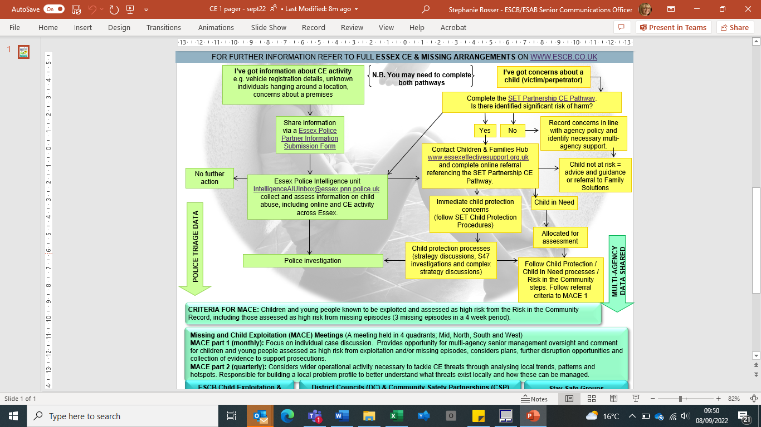](https://www.gov.uk/government/publications/criminal-exploitation-of-children-and-vulnerable-adults-county-lines/criminal-exploitation-of-children-and-vulnerable-adults-county-lines)

* 1. If the carer has concerns that the child is being exploited this must be reported to the child’s social worker and supervising social worker. If an incident occurs out of hours related to possible child exploitation the carer must inform the police and the Emergency Duty Service (EDS). If EDS is informed the carer should also ensure that both the social worker and supervising social worker are informed on the next working day.
  2. The child’s social worker will ensure a Risk in the Community (RIC) Record is started by requesting a Case Discussion with a Risk in the Community Senior Practitioner. If deemed to be high risk, the RIC Practitioner will convene and Chair a RIC meeting and both the child and carer will be invited to contribute to the discussion about these risks with partners and to develop a plan to be taken to a MACE 1 meeting for strategic oversight. The child and carer will also be offered a RIC Chat with the RIC Practitioner to discuss the exploitation, its impact on them and what they need from professionals. This plan will also be integrated into the child’s statutory plan and reviewed in their statutory review processes as well as MACE 1.
  3. RIC Officers may offer the child an opportunity to participate in bespoke goal based work aimed to reduce their vulnerabilities to exploitation.
  4. Below is the RIC pathway as agreed by the Essex Safeguarding Children Board. The [RIC pathway webpage](https://www.escb.co.uk/working-with-children/risk-in-the-community-ric/ric-pathway/) also contains further information and gides about each of these steps.

**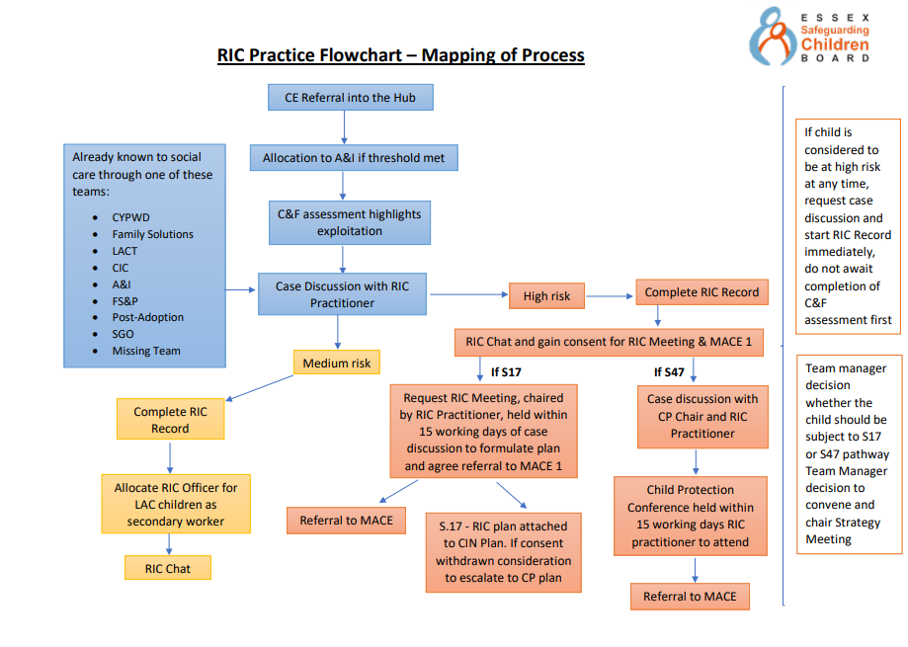**

# Appendix 1 - Flowchart for responding to a child who goes missing from their placement

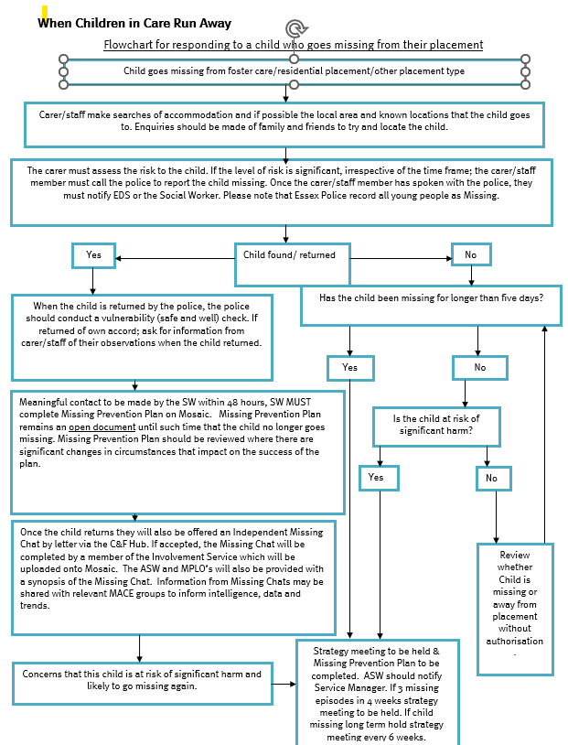

# Appendix 2 - Questions you might be asked when a child has gone missing

|  |  |  |  |
| --- | --- | --- | --- |
| Factors to be Considered | Yes | No | Not Known |
| Is the person vulnerable due to age or infirmity or any other similar factor? |  |  |  |
| Behaviour that is out of character is often a strong indicator of risk; are the circumstances of going missing different from normal behaviour patterns? |  |  |  |
| Is the person suspected to be the subject of a significant crime in progress e.g. abduction? |  |  |  |
| Is there any indication that the person is likely to attempt suicide? |  |  |  |
| Is there a known reason for the person to go missing? |  |  |  |
| Are there any indications that preparations have been made for them to go missing? |  |  |  |
| What was the person intending to do when last seen e.g. going to the shops or catching a bus and did they fail to complete their intentions? |  |  |  |
| Are there family or relationship problems or recent history of family conflict and/or abuse? |  |  |  |
| Are they the victim or perpetrator of domestic violence? |  |  |  |
| Does the missing person have any physical illness or mental health problems? |  |  |  |
| Are they the subject of a Child Protection Plan? |  |  |  |
| When previously missing have they suffered or were they exposed to harm? |  |  |  |
| Belief that the person may not have the ability to interact safely with others or in an unknown environment? |  |  |  |
| Do they need essential medication that is not likely to be available to them? |  |  |  |
| Ongoing bullying or harassment e.g. racial, sexual, homophobic or local community concerns or cultural issues etc.? |  |  |  |
| Were they involved in a violent and/or racist incident immediately prior to disappearance? |  |  |  |
| School / college / university / employment or financial problems? |  |  |  |
| Drug or alcohol dependency? |  |  |  |
| Other unlisted factors which the officer or supervisor considers should influence risk assessment? |  |  |  |
| Is the child or young person known to have Risk in the Community concerns so coerced into sexual or criminal acts (child exploitation), see flowchart for responses |  |  |  |

# Appendix 3 - Missing from Care – Quick Guide (MOU)

The role of Care providers in Essex when a child goes missing form Care

**When reporting the Young Person missing, you must:**

* **Provide** all information to the Essex Police call taker.

**\*** Some questions will be asked but when the information is not requested, please provide it regardless\*

- Description including current clothing, hair length/style, piercings, and anything else distinctive.

- Any medical conditions and medication taken.

- Mobile telephone number for missing person and the results of you calling it, how often you have called

- Do they have any mental health concerns diagnosed or undiagnosed. Include learning difficulties, ADHD, Asperger’s Syndrome and Autism, etc.

- Locations and addresses they may go to. If you do not know as they do not disclose where they go, please share this. Where have they been found before when missing?

- Please share any checks already completed by the placement this should also include the timings. Any known risks around the missing episode.

- Was there a delay in calling Essex Police to make the report and if so, why?

- If the missing person has left and was not allowed out and it is a reasonable time of day – please state why they are not allowed out:

1. Are they particularly vulnerable for any reason?
2. Is it just that they are not allowed out due to not being allowed free time?
3. Why have they not been allowed free time?
4. What causes you to worry about them?

* **Share** with Essex Police the most recent ‘planning for missing form’ by emailing it to - force.control@essex.police.uk.
* **Continue** to look for the young person and make enquiries to help locate them whilst missing, keeping Essex Police updated with any communication or sightings or the young person. This can be completed by calling 101.
* **Relay** any new information to police as soon as possible, as this may lead to further enquiries that police can undertake.

**When the Young Person is found:**

* **Notify** Essex Police immediately if you find the young person or if they return of their own accord
* **Reassure** them that you are pleased they are back safely.
* **Make** them feel comfortable, check if they are hungry etc.
* **Support** them to talk about their experience if they are ready, remember they may be tired
* **Observe** how they present on their return: for example did the young person shower, have gifts, appear unwell or under the influence of any substance, etc. Share these with Essex Police.
* **Explain** Essex Police will visit to conduct a vulnerability interview to check on their welfare.
* **Offer** an independent return interview, this will be facilitated by the Local Authority with responsibility for the child. For Essex children and young people these are called Missing Chats, offered through ECC.

# Appendix 4 - Missing Chats – information for foster carers



Independent Missing Return Interviews are a statutory requirement that must be offered after every child/young person returns from a missing episode. In Essex, this requirement is met by the Involvement Service who offer Independent Missing Return Interviews known as Missing Chats to all children and young people from Essex, age 10 - 17 yrs. returning from a missing episode via a Missing Chat letter which is sent within 72hrs of their return.

In addition to the offer by post, through our targeted approach, we will attempt to contact the children and young people by phone to offer the service and provide advice and guidance as appropriate. If accepted, Missing Chats may take place over the phone or face 2 face either at the child’s home, school or in the community, wherever they feel more comfortable.

‘Missing Chats’ are an opportunity for young people to talk freely to an independent person about how they are feeling and the reasons they went missing and what help and support might be needed. Some young people may decline the offer or prefer to speak with staff they know and have a relationship with. We are asking Foster Carers to support young people by encouraging them to engage with Missing Chat staff.

‘Carers Missing Chats’ In addition to offering Missing Chats to children and young people, we also offer Missing Chats to carers. We appreciate that the period where a child/young person was missing is likely to have been a time of great concern for you and that there may be further issues that you are also worried about. A Missing Chat is an opportunity for you to talk about what you feel is going on for the child/young person you are caring for, why you think they went missing, and what help and support may be needed to prevent them going missing again. We may need to share our discussions with appropriate workers and the police to make sure any issues raised are dealt with. We will explain this to you, so you understand what information we share and why.

When a child/young person returns from a missing episode, they and or their carers can request a Missing Chat without having to wait for the letter or call by contacting the Involvement Service via:

Email: [missingchats@essex.gov.uk](mailto:missingchats@essex.gov.uk) Phone: 07920 286299

# Appendix 5 - Planning for missing

|  |  |  |  |  |  |  |  |  |
| --- | --- | --- | --- | --- | --- | --- | --- | --- |
| 13_crest_white | | | | |  | | | |
| PHOTO OF CHILD | | | |
| Planning for Missing | | | | | | | | |
| 'All sections are to be completed by the social worker at the Placement Planning meeting, in consultation with the carer / placement provider, when a child is identified as being at risk of going missing'. | | | | | | | | |
|  | Name of child: |  | | Date of Birth: | |  | Age: |  |
|  | Current Address and tel number: | |  | | | | | |
|  |  | |  | | | | | |
|  |  | |  | | | | | |
|  |  | |  | | | | | |
|  | Point of contact for Placement / Carer: Name/Number/Position Held: | | | | | | | |
|  | Legal Status of the Child: Who has parental responsibility and which care order are they under: | | | | | | | |
|  | Person Completing form: Name/Position Held: | | | | | | | |

|  |
| --- |
| **BACKGROUND HISTORY OF THE CHILD** |
|  |

|  |  |  |
| --- | --- | --- |
| **CHILD’S DETAILS** | | |
| **SURNAME:** | | **FORENAME(S): (include Alias names/nicknames)** |
| **Date of Birth:** | **Age:** | Place of Birth: |
| Sex: Male  Female | | Nationality: |
| Immigration status (if applicable): | | |
| Language spoken: | | |
| Photograph Obtained: **Yes**   **To be e-mailed**   **([compactphotos@essex.pnn.police.uk](mailto:compactphotos@essex.pnn.police.uk))** | | |

|  |  |  |
| --- | --- | --- |
| **ETHNIC APPEARANCE** | |  |
| 1 White North European |  |
| 2 White South European |  |
| 3 Black |  |
| 4 Asian |  |
| 5 Chinese/Japanese or south east Asian |  |
| 6 Middle Eastern |  |
|  | |

|  |  |  |  |
| --- | --- | --- | --- |
| **CURRENT DESCRIPTION** | | | |
| Height:      ft      inches or      M      cm | | | Shoe Size: |
| Handed: Left  Right  Ambi | Eyewear: Glasses  Contact Lenses  Not Worn | | |
| Hair Type: (e.g. short, cropped) | | Hair Colour: | |
| Hair Features: | | Facial Hair: | |
| Eye Colour: | | Accent: | |
| Build: Please describe: | | Complexion: | |
| Sexuality: (if known) | | | |
| **Habits/Peculiarities/style of dress:** | | | |

|  |  |  |  |  |  |  |  |  |
| --- | --- | --- | --- | --- | --- | --- | --- | --- |
| **VULNERABILITY / WARNING** | | | | | | | | |
| Firearms |  | Weapons |  | | Violent |  | Suicidal |  |
| Physical health concerns |  | Allergies |  | | Contagious |  | Self-Harmer |  |
| Trafficking |  | Gangs |  | | Drugs |  | CSE |  |
| Radicalisation |  | FGM |  | | Criminal Exploitation |  | Trauma  Bereavement  Other | |
| **Vulnerability / Warning Notes:** if any of the above are ticked please give detailed explanations, to assist in informing risk assessments and mitigating risk should the child go missing: | | | | | | | | |
| **Identifying Marks:** (scars/tattoos/piercings/dental/peculiarities) | | | | | | | | |
| Childs mobile phone number and the make / model of phone: | | | | Childs e-mail address: | | | | |
| Childs social network profiles i.e. Facebook / Twitter / Instagram / Snapchat – To include their profile names | | | | | | | | |

|  |  |  |  |  |  |  |  |  |  |  |  |  |  |  |  |  |  |  |  |  |  |
| --- | --- | --- | --- | --- | --- | --- | --- | --- | --- | --- | --- | --- | --- | --- | --- | --- | --- | --- | --- | --- | --- |
| **ADDITIONAL INFORMATION** | | | | | | | | | | | | | | | | | | | | | |
| Bank Card Details: (If Known) | | | | | | |  | | Card Provider: | | | | | | | | | |  | Card Type: |  |
|  |  | | | | | |  | |  | | | | | | | | | |  |  |  |
|  | Name on Card/Current location: (if known) | | | | | | | | | | | |  | | | | | | | |  |
|  | Cash: |  | | | | | | | |  | | | | | | | | | | |  |
|  | | | | | | | | | | | | | | | | | | | | |  |
| School / College / Place of Education Details: | | | | | | | | | | | | | | | | | | | | | |
| Phone Number: | | | | | | | | | | | | | | | | | | | | | |
| Disability: Yes  No  Please give details: | | | | | | | | | | | | | | | | | | | | | |
| Details of any illness known and/or medication: | | | | | | | | | | | | | | | | | | | | | |
| Religion: | | | | | | | | | | | | | | | | | Doctor’s Details: | | | | |
| Access to a Vehicle? Details of driver no, registration number etc  Access to a bus pass? Details eg number and issuer | | | | | | | | | | | | | | | | |
| Phone Number: | | | | |
| Languages Spoken: | | | | | | | | | | | | | | | | | Dentist details: | | | | |
| Blood Group (if known): | | | O+ |  | O- |  | | A+ | | |  | A- | |  | | |
| B+ |  | B- |  | | AB+ | | |  | AB- | |  | | | Phone Number: | | | | |
| Passport Details: (consider DV/HBV/Forced marriage risk) | | | | | | | | | | | | | | | | | | | | | |
|  | Passport Number: | | | | | | | | | | | | | |  | Name on Passport: | | | | |  |
|  |  | | | | | | | | | | | | | |  |  | | | | |  |
|  | Current location of Passport: | | | | | | |  | | | | | | | | | | | | |  |
|  | | | | | | | | | | | | | | | | | | | | |  |
| Are there any memorable dates i.e. the death of a family member or friend? Yes  No | | | | | | | | | | | | | | | | | | Details: | | | |
|  | | | | | | | | | | | | | | | | | |  | | | |

|  |  |
| --- | --- |
| **ASSOCIATE INFORMATION** | |
| Known friends / associates / family members – please regularly update this form with any new associates or locations the young person has mentioned. | |
| |  |  |  |  |  |  | | --- | --- | --- | --- | --- | --- | |  | **Name** | **Address** | **Association** | **Phone Number** | **Associated Risks** | | **1** |  |  |  |  |  | | **2** |  |  |  |  |  | | **3** |  |  |  |  |  | | **4** |  |  |  |  |  | | **5** |  |  |  |  |  | | **6** |  |  |  |  |  | | **7** |  |  |  |  |  | | **8** |  |  |  |  |  | | **9** |  |  |  |  |  | | **10** |  |  |  |  |  | |  |  |  |  |  |  | | |
| Missing person previously accompanied by (If left with other residents previously): |

|  |  |
| --- | --- |
| **PREVIOUS ADDRESS** | |
| Premises (name and/or house number): | Postcode: |
| Street: | Home Phone: |
| District: | Work Phone: |
| Town: | Mobile Phone: |
| County: |

|  |  |
| --- | --- |
| **MISSING EPISODE HISTORY** | |
| Missing episode history: |  |
| Previous locations found: |  |
| All recent information: |  |
| Significant places of interest: |  |



|  |
| --- |
| **Completed form to be emailed securely to:**  [**missingpersonliaisonofficers@essex.pnn.police.uk**](mailto:missingpersonliaisonofficers@essex.pnn.police.uk) |

* *It should be explained to the child that this information will be held by the police in a reactive capacity. It will only be used should the child go missing. At that point this information would be used to help inform the police in order to mitigate any risk to the child and safely locate them.*